**Assignment 3_3**

1. Test whether two vectors are exactly equal (element by element).

vec1 = c(rownames(mtcars[1:15,]))

vec2 = c(rownames(mtcars[11:25,]))

**identical(vec1, vec2)**



2. Sort the character vector in ascending order and descending order.

vec1 = c(rownames(mtcars[1:15,]))

vec2 = c(rownames(mtcars[11:25,]))

**sort(vec1)-ascending**

**sort(vec2)-ascending**

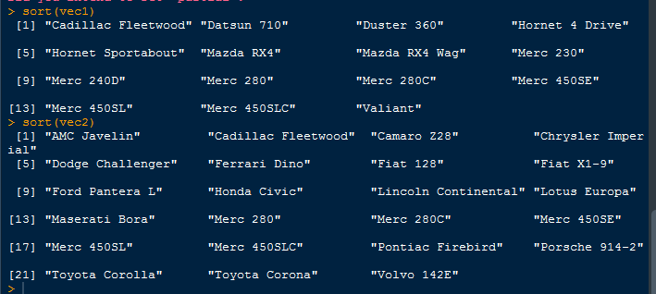

**sort(vec1, decreasing=TRUE)**

**sort(vec2, decreasing=TRUE)**

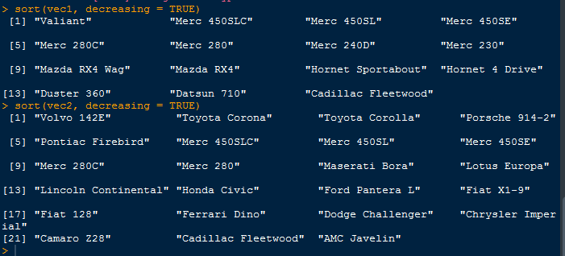

Sort(union(vec1, vec2))

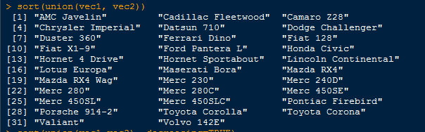

Sort(union(vec1, vec2), decreasing=TRUE)

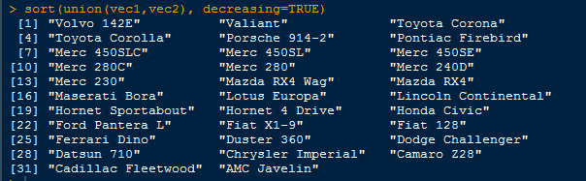

3. What is the major difference between str() and paste() show an example.

**Str() –Provides the information of an object.**

**Paste()-Concatenates the strings.**

4. Introduce a separator when concatenating the strings.

**Paste(“My name is”, “Supriya”, sep=”-“)**

**Cat(“My name is Supriya”, “I goto R Analytics class”, sep=”-“)**

